Personal Narratives

Lesson #1: Focusing on a Small Moment in Time

1. Show students several snapshots of moments in time.

2. Each student is to think of themselves as a photographer, but instead of taking pictures with a real camera, they are going to choose a moment, freeze it in their mind’s eye, and then reconstruct that picture with words so that a reader can visualize the “word picture.” These moments are called snapshots, and not only do these moments allow the reader to see what is going on but also to hear, smell, taste, and feel what is going on.

3. Students should write down the following definition of a snapshot in their Writer’s Handbooks.

Snapshots: is a photo made of words of ONE MOMENT IN TIME. A snapshot is SO detailed that the reader gets a really clear picture in their head as they read. Snapshots help the reader SEE (& hear, smell, etc.) what is going on in your story.

Remember-A snapshot is ONE MOMENT in time-not a whole baseball game or a whole trip to Cedar Point, etc.

4. Pass out handout with excerpts of snapshots from novels (Maniac Magee and James and the Giant Peach). Choose different students to read the excerpts out loud to the class. Discuss why and how the author uses words to create vivid snapshots of what is going on in the story.

5. Ask students how long they think each snapshot took in real life (minute or less). Point out how much was written to create that one minute or less (especially the Maniac Magee one).

6. Have students select a small moment in time they want to write their personal narrative about and sketch this moment.

Excerpts from the novels:

From Roald Dahl’s James and the Giant Peach:

Aunt Sponge was enormously fat and very short. She had small
piggy eyes, a sunken mouth, and one of those white flabby faces
that looked exactly as though it had been boiled. She was like a
great white soggy overboiled cabbage. Aunt Spiker, on the other
hand, was lean and tall and bony, and she wore steel-rimmed
spectacles that fixed onto the end of her nose with a clip.

From Maniac Magee:

Maniac had seen some amazing things in his lifetime, but nothing as amazing as that house. From the smell of it, he knew this wasn’t the first time an animal had relieved itself of the rugless floor. In fact, in another corner he spotted a form of relief that could not be soaked up by newspapers.
Cans and bottles lay all over, along with crusts, peelings, cores,
scraps, rinds, wrappers—everything you would normally find in a
garbage can. And everywhere there were raisins.
As he walked through the dining room, something—an old
tennis ball—hit him on top of the head and bounced away. He
looked up—into the laughing faces of Russell and Piper. The hole
in the ceiling was so big they could both have jumped through it at
once.
He ran a hand along one wall. The peeling paint came off like
cornflakes.
Nothing could be worse than the living and dining rooms, yet
the kitchen was. A jar of peanut butter had crashed to the floor;
someone had gotten a running start, jumped into it, and skied a
brown, one-footed track to the stove. On the table were what ap-
peared to be the remains of an autopsy performed upon a large bird,
possibly a crow. The refrigerator contained two food groups:
mustard and beer. The raisins here were even more abundant. He
spotted several of them moving. They weren’t raisins; they were
roaches. (pp.131-132).

Name:_____________________________

Personal Narrative:
My Snapshot

________________________________________________________________________________
_______________________________________________________________________________
________________________________________________________________________________
________________________________________________________________________________

Lesson #2: Show, Don’t Tell

1. Ask students: Which of the following endings is better? Why?

A. I had finally finished the long race across the Sahara desert.

B. As I crossed the finish line, a surge of excitement went through my body. I knelt down and kissed the ground. Finally, after weeks of trudging through endless sand dunes, it was over.

2. Allow students to discuss the two endings. The second ending is better because it gives the reader a vivid picture of what happened. The first ending only tells. When writing, we want the reader to be able to see, taste, smell, hear and sense things just as we are. It is important to use details that invoke imagery.

3.Write the following sentence on the board: Today the weather was nice.

Ask students: How could we add more details to this sentence? We don't know what the weather was like at all. Was it sunny, raining, cloudy, or what?

Ask students orally to think of ways to better describe the nice weather, jot down ideas on the board.

4. Inform students that they must add more details to the following sentences so that they are more descriptive.

Write the following sentences on the board and instruct students to rewrite them using the reporter's formula.

Bill is handsome.

Susan is athletic.

I am enjoying school today.

Eggs are fun to throw.

5. Have students complete the Show, Don’t Tell Handout independently.

6. For homework have each student create a paragraph that has at least three showing sentences.

Name:______________________

Show, Don’t Tell!

I was happy. | I was shy.
I was surprised. | I was sad.
I was hot. | I was embarrassed.
I was sick. | I was having fun.

Lesson #3: Adding Sensory Details
1.Talk about the five senses. Ask the students what words come to mind when the you says, "Smell." Examples of responses include "sniff" and "fragrance." Do this for all five senses: sight, smell, touch, hear, and taste. Record their answers on the chalkboard.
2. Divide worksheets into five sections. (Could be five columns, or five bubbles, as long as each worksheet has a line for the object and five sections.) Each section is labeled with one of the five senses.
3. Pick an object and have students write descriptive words in each of the five sections. Remind them that they may not actually taste anything without permission! Each student should write at least three words under each sense.
Example: Object is salt.
Looks like: white, small, shiny.
Feels like: grainy, soft, slips through my fingers.
Tastes like: bitter, salty, bad.
Sounds like: quiet, rustle, silent.
Smells like: faint, odorless, mildly bitter.
4. Have the class do this for a variety of objects, for example:
- Rock
- Flower
- Pencil
- Sugar
- Cucumber
- Use your imagination.

5. When the students have the hang of it, let them each privately think of an object to describe. They quietly fill in the bubbles for the five senses. They are not to tell each other what object they chose.
6. Collect the papers, and mix them up. Then, choose one and read the descriptive words for each of the five senses. Let students raise their hands to try to guess the object being described.
7. After doing this a few times, let the students think of another object, and try again. Repeat the process.
8. When finished, ask them if it was easier to come up with descriptive words the second time around. Ask them what they got out of the activity, such as an appreciation for the importance of good description.
Name:__________________

Sensory Details

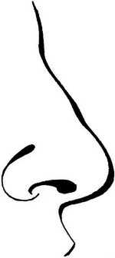

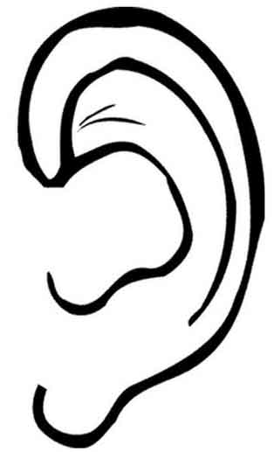
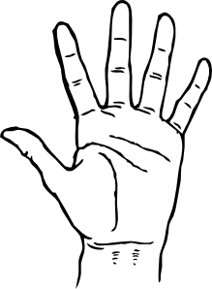

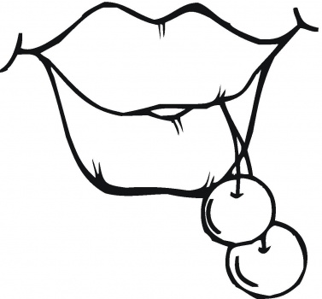

Lesson #4: Personal Narrative Planner

- Review narrative elements.

- Model filling out personal narrative planner.

- Have the children fill it out as a prewriting strategy.

Name:_________________________

Personal Narrative Planner

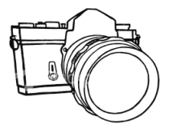
Personal Narrative Snapshot
__________________________________________________________________________________
__________________________________________________________________________________

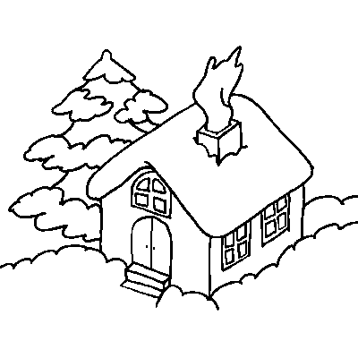
Setting
_____________________________________________________________________
_________________________________________________________________________________
_________________________________________________________________________________

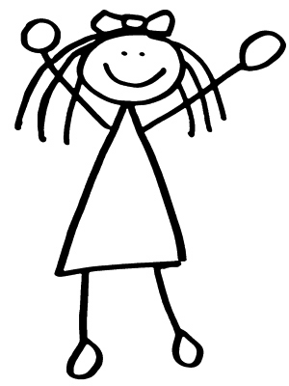
Characters
__________________________________________________________________________________
__________________________________________________________________________________
__________________________________________________________________________________

First
__________________________________________________________________
___________________________________________________________________

___________________________________________________________________

Next
___________________________________________________________________
___________________________________________________________________

___________________________________________________________________

Last
___________________________________________________________________
___________________________________________________________________

___________________________________________________________________

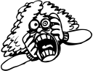
“Show, Don’t Tell” Emotions
_______________________________________________________________________
_________________________________________________________________________________
_________________________________________________________________________________

Sensory Details
_________________________________________________________________________________________
__________________________________________________________________________________
_________________________________________________________________________________
__________________________________________________________________________________
__________________________________________________________________________________
_______
__________________________________________________________________________________

___________________________________________________________________________________
___________________________________________________________________________________
____________________________________________________________________________
___________________________________________________________________________________

